**Chapter 12: The production function approach to understanding growth**

**Production function:**

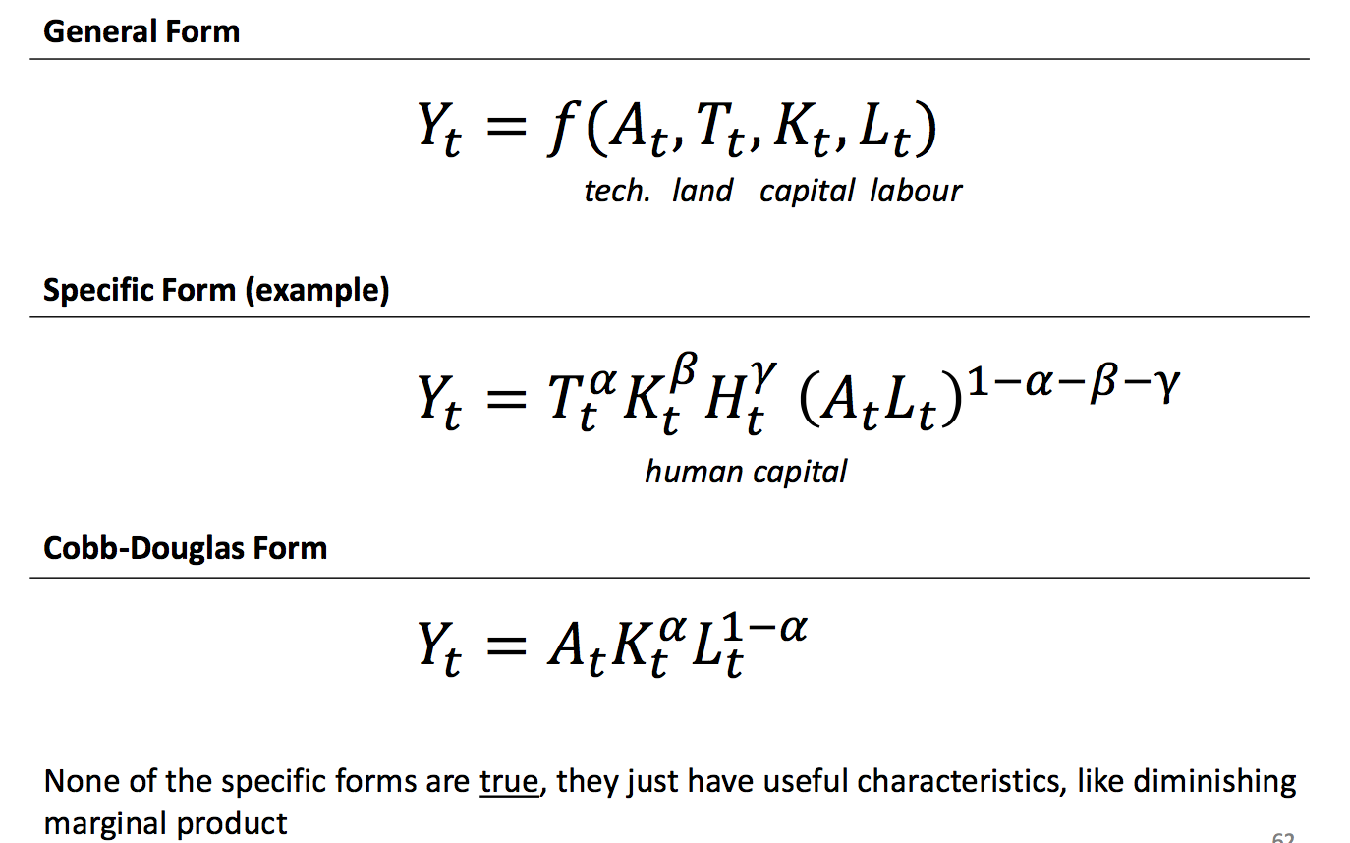

* 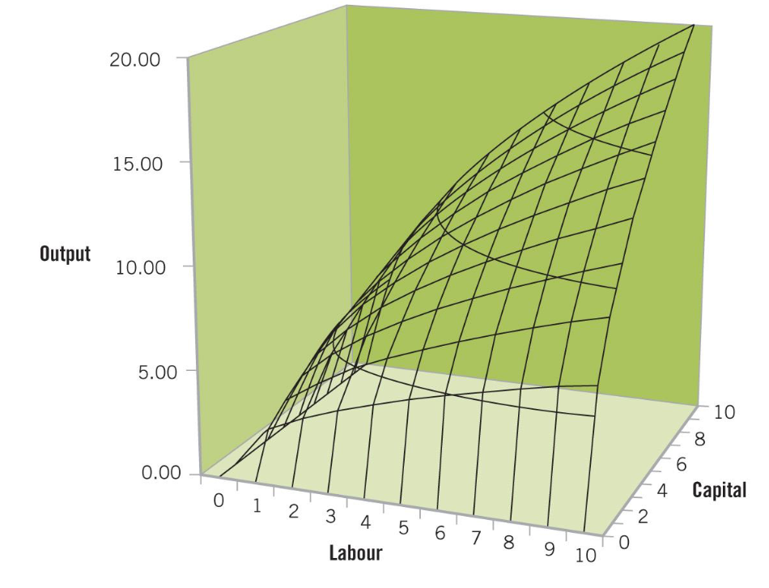The cobb-Douglas product function can be plotted on a three-dimensional surface plot. More capital and more labour increase output:
* Two dimensional production function for capital:

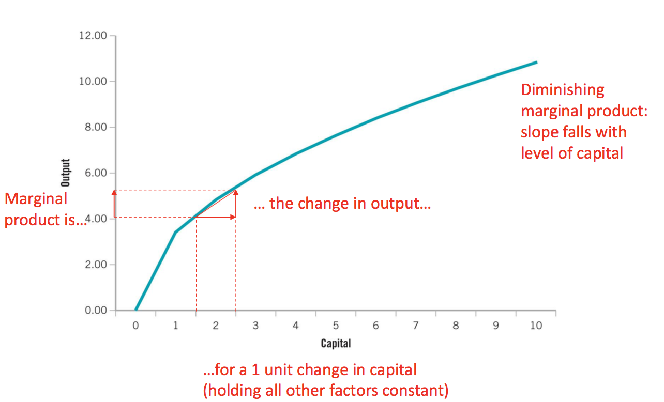

* The marginal product can be found by partially differentiating the production function with respect to each factor:

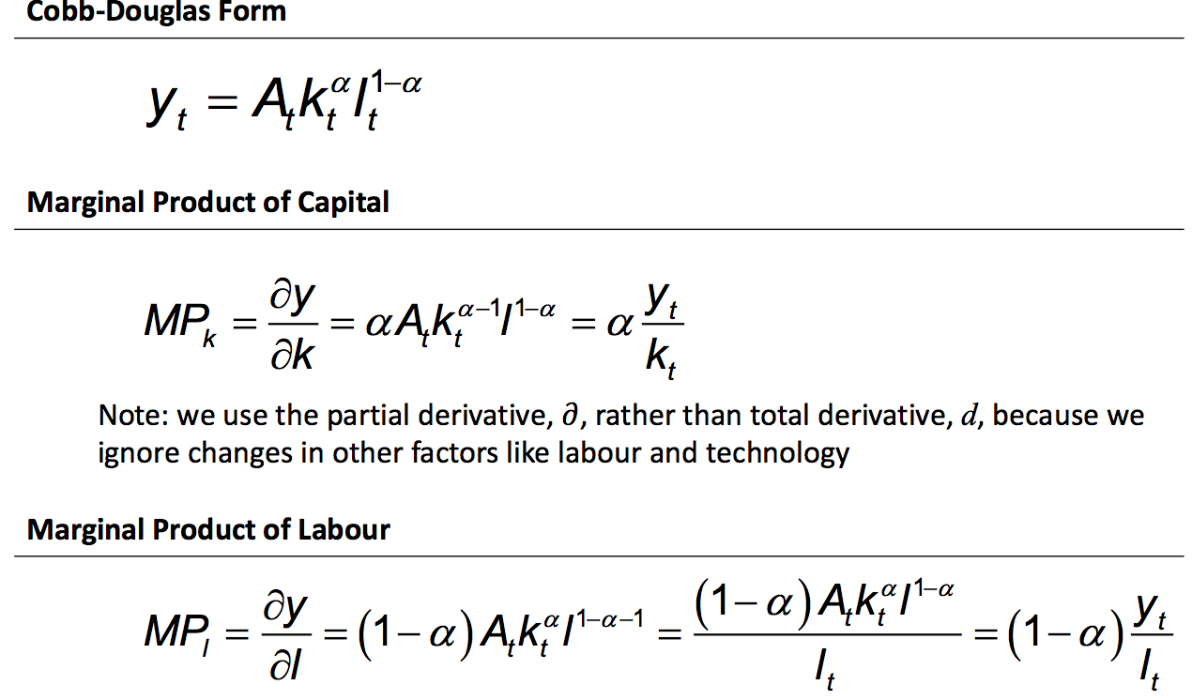

Cobb-Douglas Production Function: Output Y is a function of three sectors, labour technology and capital

Marginal Product of Capital: Measure changes in output per unit of change in capital

Using partial derivative (we are only interested in the change in one variable and assume that the other two variables (labour and technology) are held constant)

If you have more capital, marginal product goes up;

If you have less capital, marginal product goes down.

Marginal Product of Labour: Again, using partial derivative.

If you have more labour, marginal product goes up;

If you have less labour, marginal product goes down.

However you cannot have infinite amount of output by adding more capitals or labours in as they have limited , but you can have infinite growth of output by developing technology.

**Marginal Product and Real Wages**

* Factors earn their marginal product in a perfectly competitive environment (not always the case) because firms maximise profit.
* How the firm make profits:

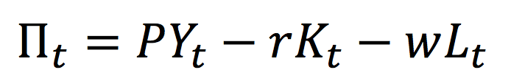

profits equal price * quantity produced, less rent paid to capital, less wages paid to workers

* The real wage you pay your worker is equal to their marginal product. The firm will add workers until they maximise profits and the extra worker cannot bring more profit, which is when marginal product is 0.

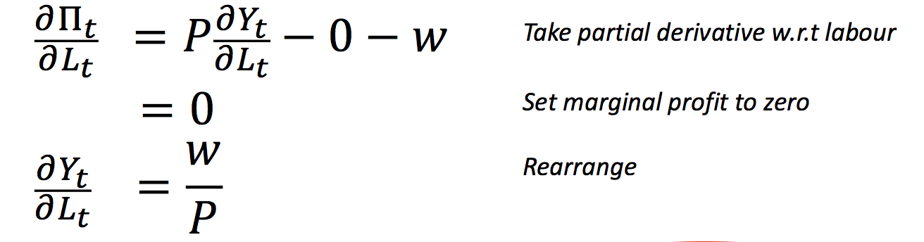

Marginal product of labour = real wage

* The Cobb-Douglas function means that a fixed share of income goes to labour (1-) and capital ()

The amount paid to each worker is:

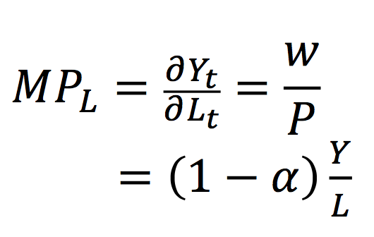

The amount paid to all workers is:

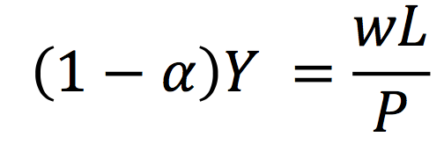

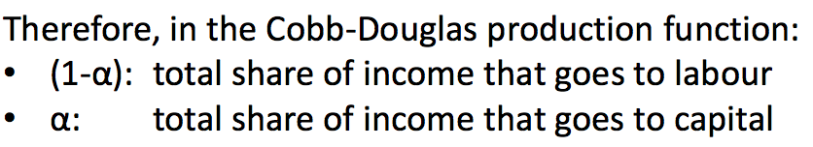

* The share of Australia’s total income going to labour has fallen over the past 40 years, which can lead to higher inequality
* The labour share in come varies across industries, depending on how labour intensive they are. Eg. Agriculture and mining has high whereas services has low.

**Increase the amount of factors used in production**

* In the Cobb-Douglas function, adding 50% more labour and 50% more capital raises output by 50%. This is called “constant returns to scale”.

If they add up to less than 1 --- diminishing returns to scale

If they add up to more than 1 --- increasing returns to scale

* Example: Constant Returns to Scale

Starting with initial levels of capital and labour:

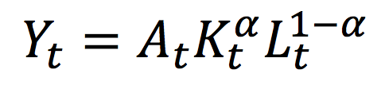

1. if we add 50% to capital and 50% to labour then:

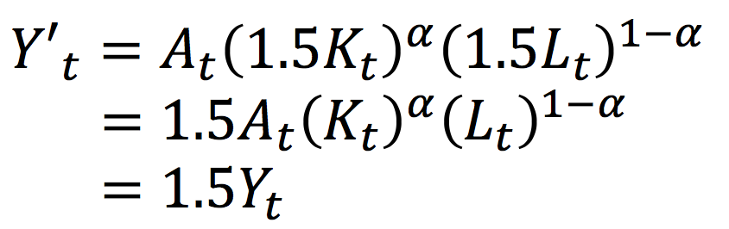

We also add 50% to output.

1. If only capital increase by 50%, then output will increase by approximately % .

The bigger the change in capital, the worse the approximation will be

Example: Returns to a single factor

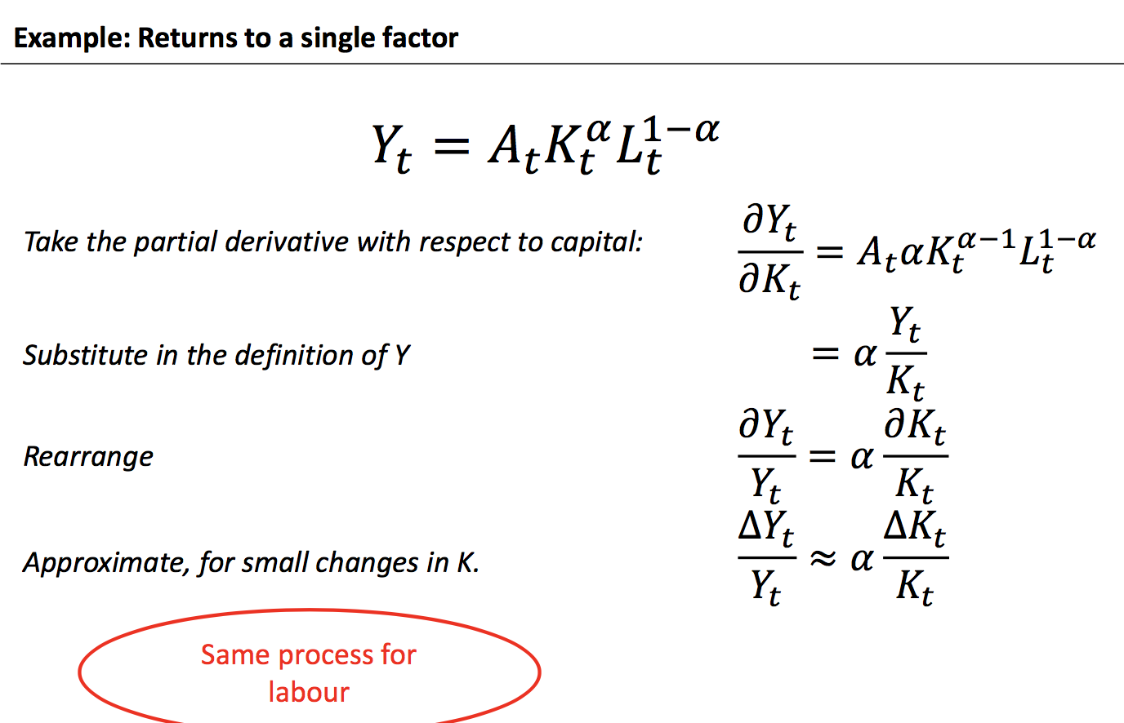

This is the percentage change.

The returns to an additional unit of capital can be illustrated on a 2 dimensional plot

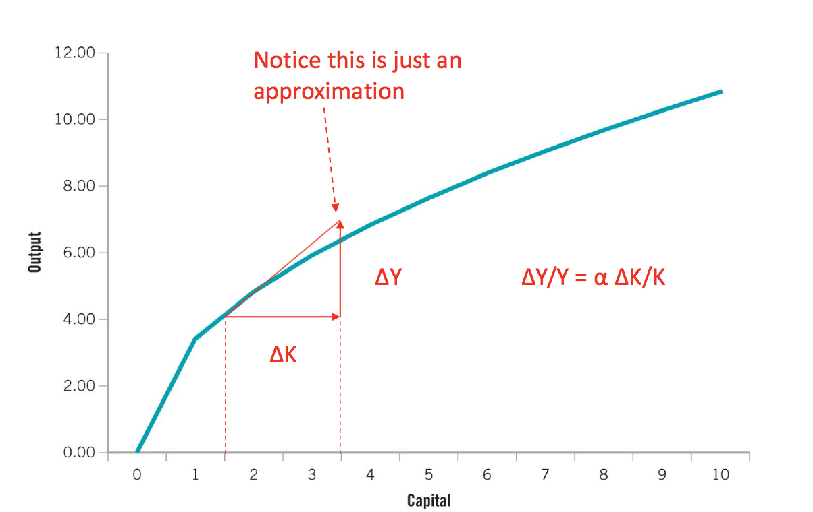

The partial derivative is equal to the slope of the line

1. An increase in TFP (technology) increases output by the same amount

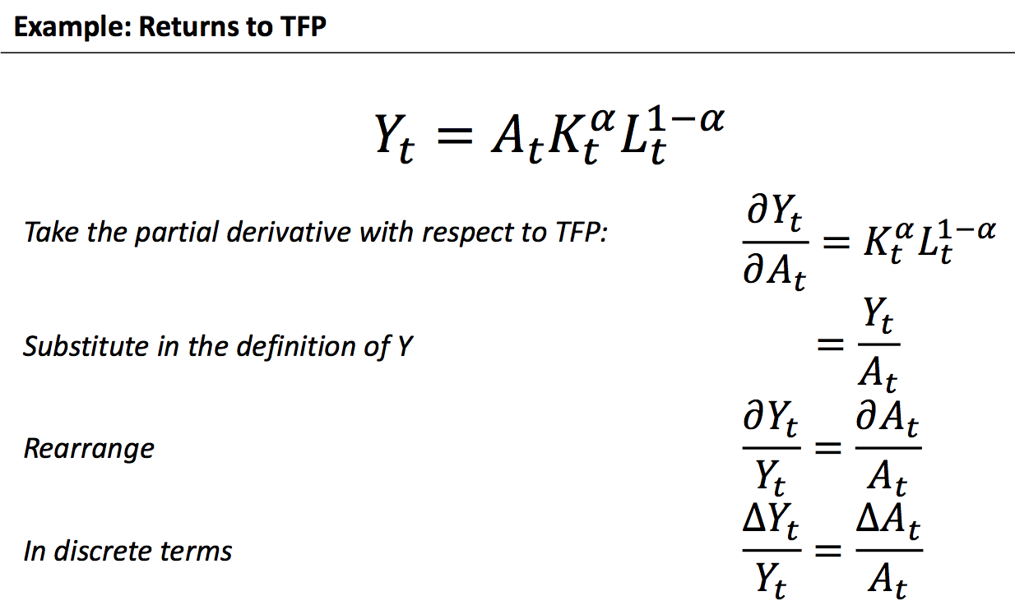

**Productivity**

* Productivity is usually taken to mean “labour productivity” or “total factor productivity”
* Labour productivity: The amount produced by one unit of labour

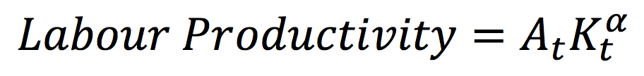

* Total Factor Productivity (TFP)

The amount produced by one unit of all factors – except technology

Describes the efficiency with which factors are combined

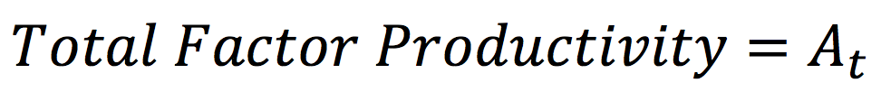

**Growth Accounting Framework**

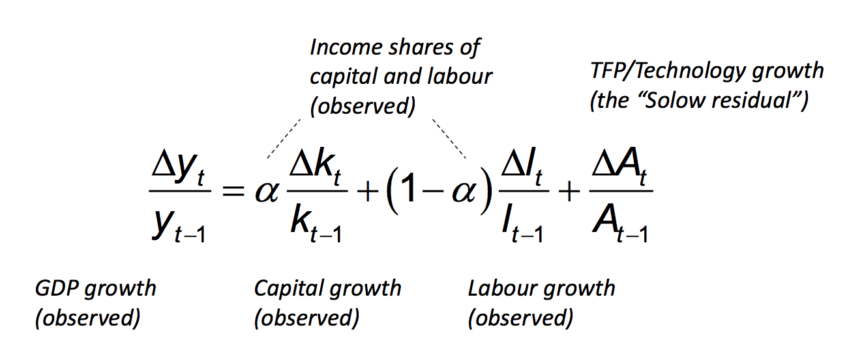

* Facts: In Australia, growth in TFP and labour have been the most important for overall GDP Growth. In contrast, capital construction was crucial in Japan and in the post WWII years.

While in recent year Japan’s shrinking population has been a drag on overall growth. The growth in the Asian tiger economies from 1960-1994 was mostly driven by capital accumulation.

* Summary:
* The production function is a representation of the process by which firms combine the primary factors of production, capital and labour, in order to produce output.
* The demand for capital and labour are determined by marginal product of labour and capital, which is subjected to diminishing returns.
* The market for capital is equilibrium when the rental rate is equal to the marginal product of capital.
* The market for labour is in equilibrium when the real wage rate is equal to the marginal product of labour.
* The Cobb-Douglas production function is often used in economic analysis.
* Growth accounting is the name given to the empirical analysis of the relative contributions made by capital, labour and total factor productivity to a country’s rate of economic growth.

**Chapter 13 – Saving, capital formation and Comparative Growth**

**The Solow-Swan model**

* Study how capital explains economic growth

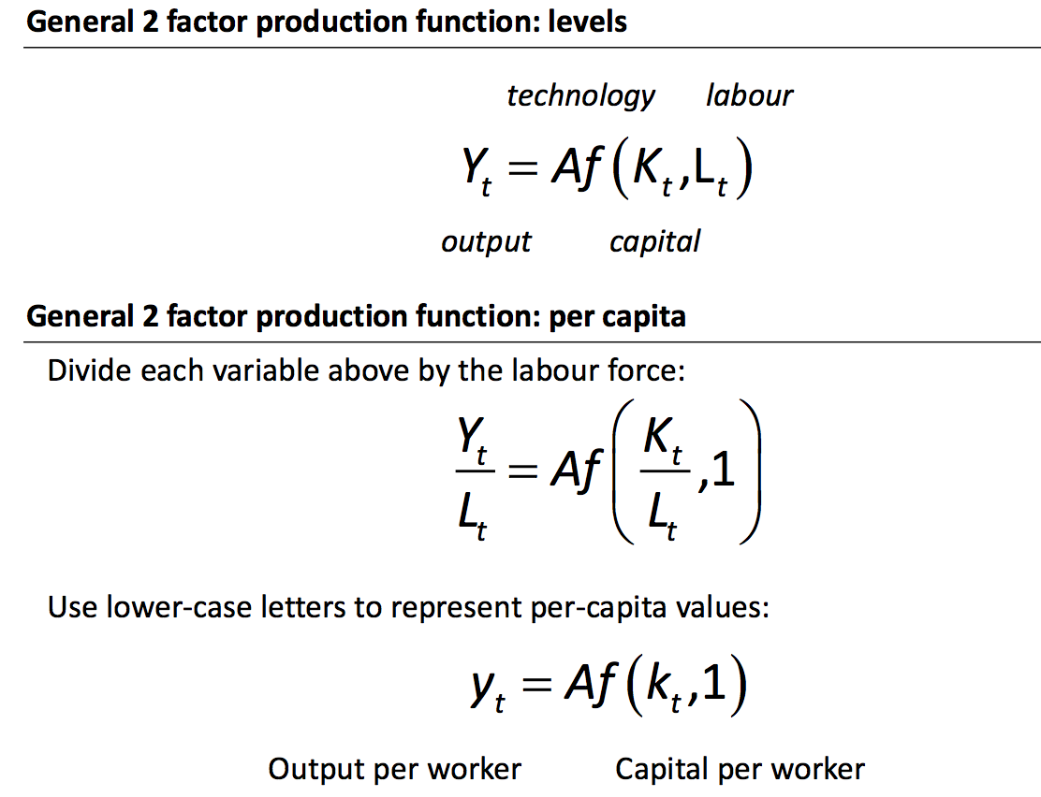

* Three ways that capital per worker can change:

1. Buy more capital (investment)
2. Employ more worker
3. The value of capital diminish overtime as it used out (depreciation)

* Capital can change because of investment, depreciation or population growth

**Investment in capital**

* The stock of capital per worker only increases with “net investment”, after replacing depreciation.
* Increase in capital per worker is investment less depreciation less population growth:

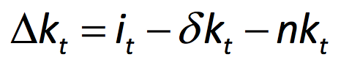

* Investment can be split into “net” and “replacement” investment

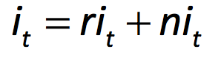

* “Replacement” investment just makes up for depreciation and population growth:

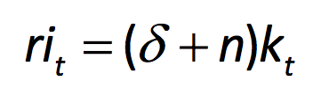

* So capital per worker only increases with “net investment”:

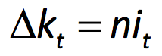

**Savings (In a closed economy):**

* Investment must be finance by savings in a closed economy
* Assume economy saves a fixed share of output:

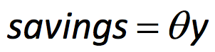

Saving is used to finance investment (both ri and ni):

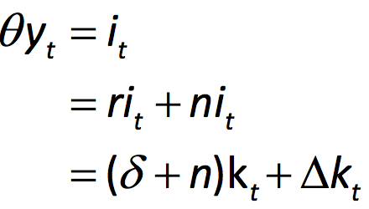 (ri: replacement investment; ni: net investment)

Or rearranging shows that the change in capital depends on savings less replacement:

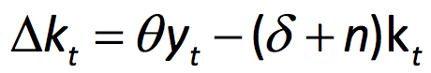

Theta is the saving rate (percentage of income you saved), y is output per worker

* The Solow-Swan diagram illustrates how savings affects GDP. If savings > replacement then the economy grows:

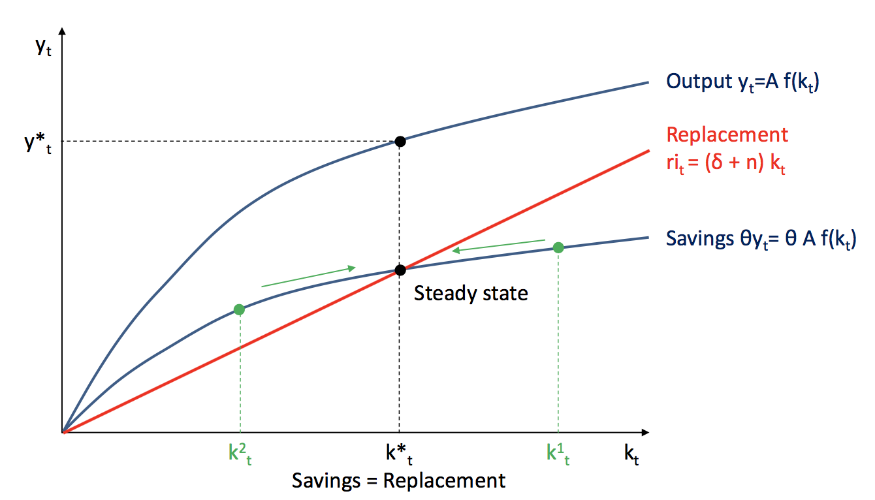

If you save exactly the same replacement as savings, then it is a steady state

Red line – Amount of investment you need to keep up (depreciation + population growth)

Blue line – your saving rate

* If the gap between your saving and replacement curve is high then you can accumulate capital in a short amount of time
* The Solow-Swan model predicts that GDP in poor countries will catch up to rich countries (“convergence”), because they have a higher MPK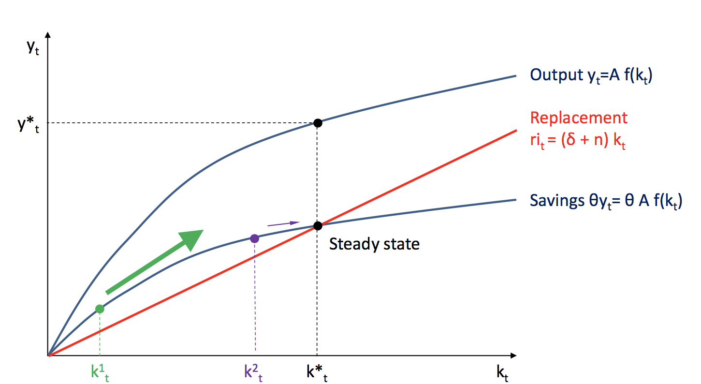
* Conditional convergence:

Convergence can be found for economies that are relatively open. Openness facilities the transfer of technology across countries, making a common steady state more likely than for countries that are relatively closed.

* The Solow-Swan model predicts that economies will stop growing when they reach their steady state, unless they increase technology (A)

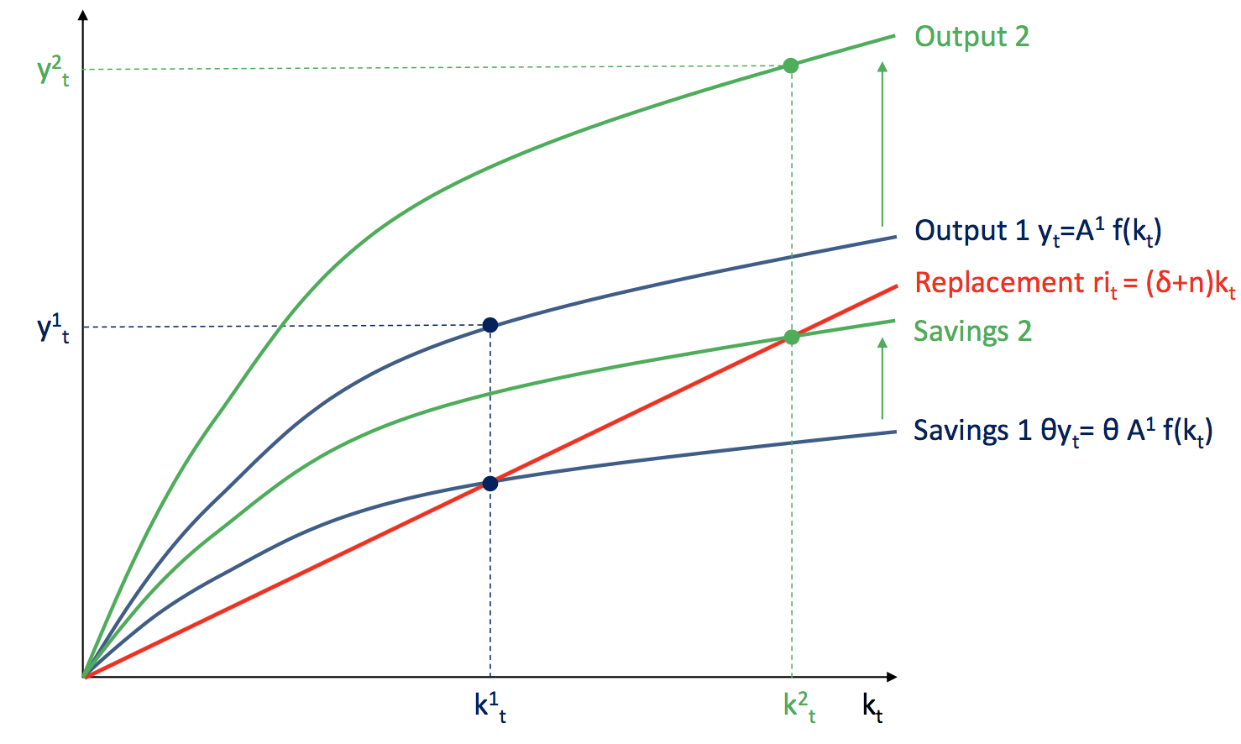

* The Solow-Swan model suggests that increasing savings will increase output in the long run: We increase our saving and hence shift the steady state higher – saving more stimulates the economic growth.

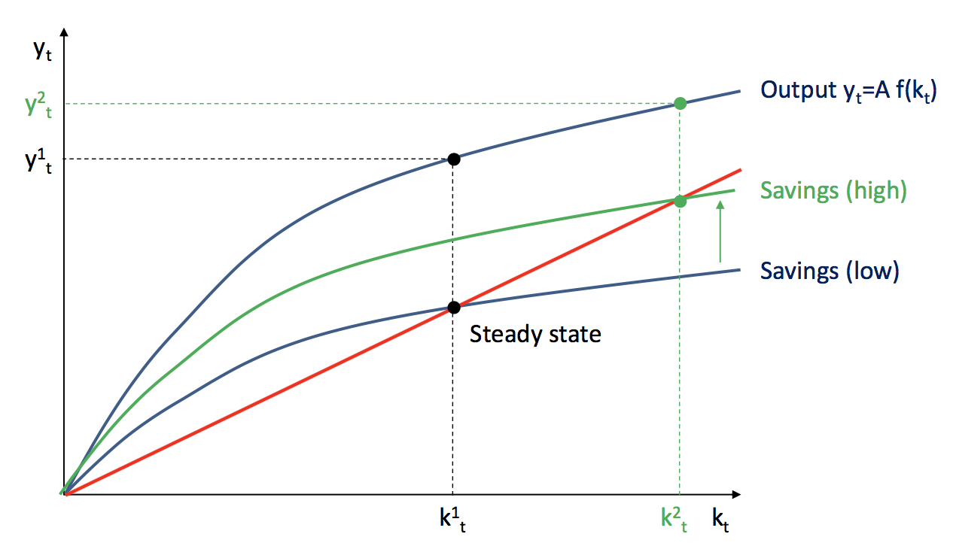

* However, Kaynes’ “Paradox of Thrift” suggests that increasing saving will reduce output.

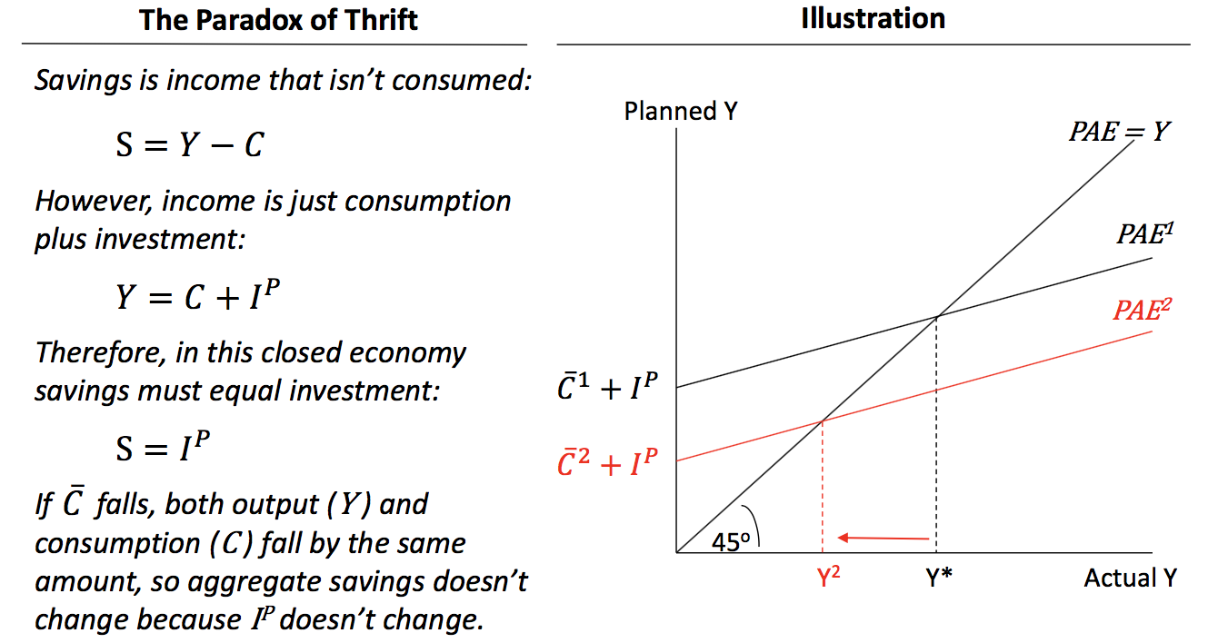

* Reconcile the two model:

The difference is that the **Paradox of Thrift refers to the short run**, when supply is determined by **demand**:

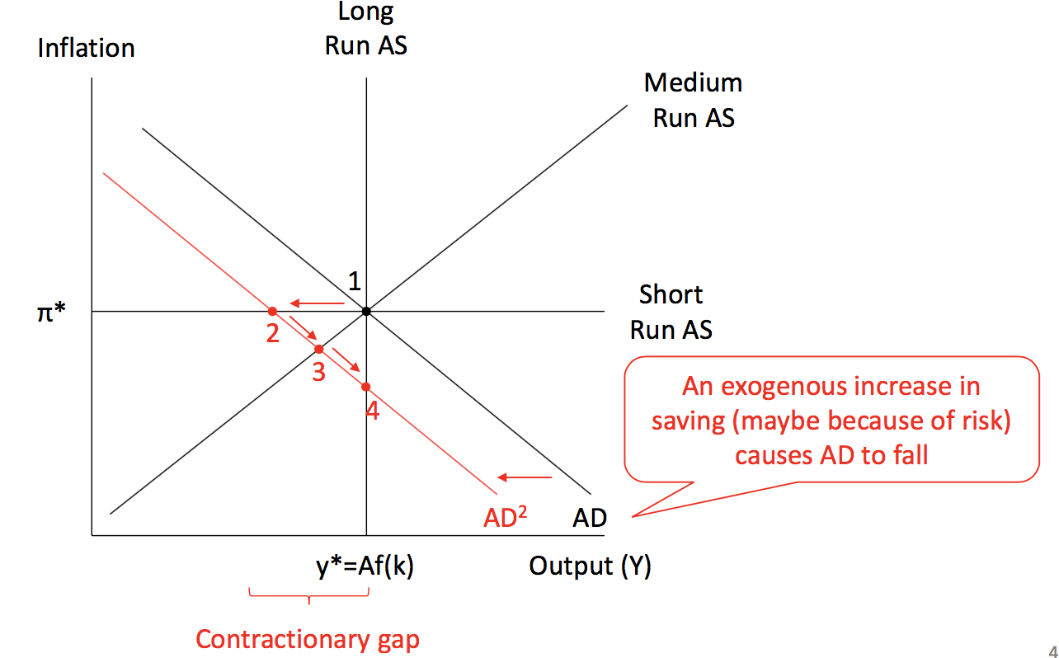

* **The Solow-Swan refers to the long run**, when supply is determined by **capital**, techonology, etc

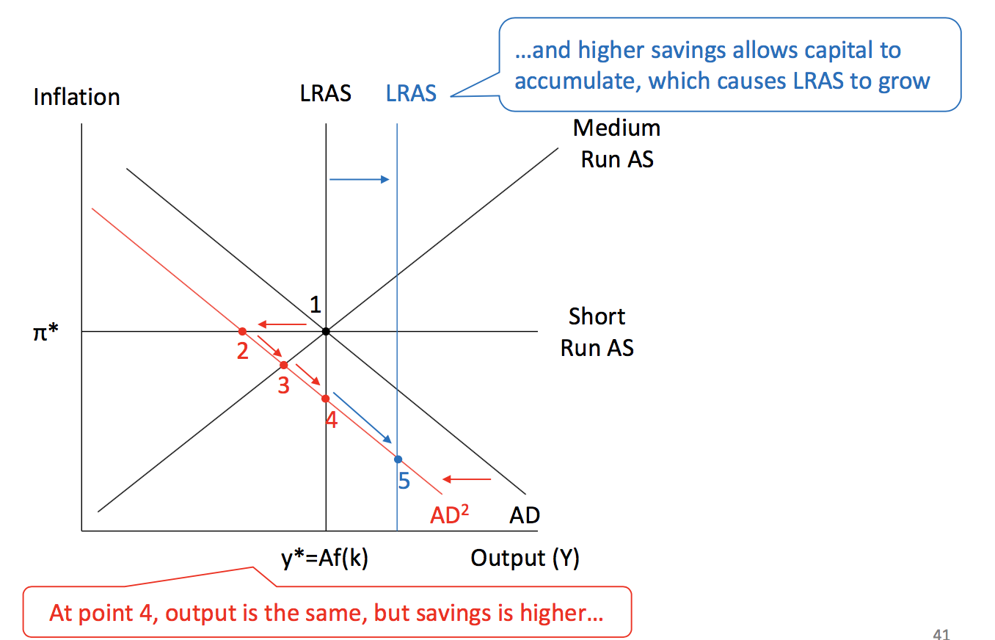

In the short run business just sell as much as they can given what the prices are. Eg. If a raining day (short run), coles are selling less than they can and shift aggregate demand to the left. If keep raining for a few months, coles will have to lower the price (medium run). In the long run coles will have to keep lower their price to attract customers.

* Summary:
* The Solow-Swan model is based on a production function expressed in per capita terms, so that the level of per capita output (or income) depends on total factor productivity and the ratio of capital to labour
* The Solow-Swan model predicts that there will be no further growth in per capita income once the economy has reached its steady state
* The law of diminishing marginal productivity of capital means that countries with relatively low per capita capital stocks will grow at a faster rate than countries with high per capita capital stock
* Countries with similar characteristics tend to converge to the same steady state capital-labour ratio.